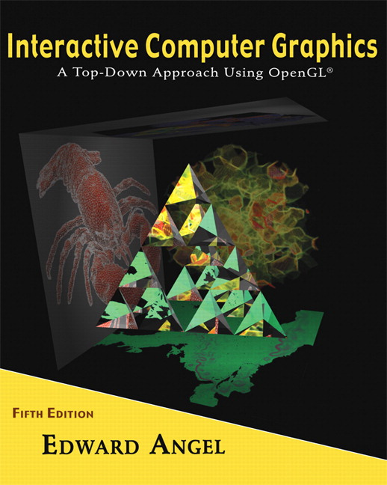

Name: ______________________ Term # ____
Programming Assignment 4
(100 points)

The Programming Assignment is to be turned in the first ten minutes of the due date class as:

Hardcopy (with your terminal #!)
Source Code and screenshots that shows that your Visual Studio 2008 “Programming Assignment 4” PROJECT compiles and runs!

Electronic: Submit the Visual Studio2008 “Programming Assignment 4” zipped PROJECT to BB so you can run it in 200 PGH!

“HOUSE - Summer 2010” Color & Shading and Texturing Instructions
(The file “House Summer 2010.pdf” contains the specifications for the house.)

“CLOCK - Summer 2010” Color & Shading and Texturing Instructions
(The file “Clock Summer 2010.pdf” contains the specifications for the clock.)

1. The glutCreateWindow OpenGL call will take as parameter “YourLastName Final House”.
2. Start with the LastNameHouse.c that you have created in Programming Assignment 3 and call the file LastNameFinalHouse.c.

3. Clock with moving hands
Use curves and surfaces of any kind of primitives to generate the given clock.

4. Navigating:
First, the discrete reposition & orientation of the light should be linked to a menu , key, etc.
Second, the LookAt needs to be amended with the following camera positions:
- at the door looking toward the middle back wall, back right top corner, back top left corner - 3.
- in the middle of the house looking at the same as above PLUS back towards the front door. - 4.
Attach these fixed positions to a menu, key, etc.

Get screenshots of the “YourLastName Final House” for each view and please comment on what the screenshot is about.

